**PROJECT REPORT ON**

**“ VIRTUAL ASSISTANT FOR VISUALLY IMPAIRED “**

**SUBMITTED TO**

“ **COMPSOFT TECHNOLOGIES “**

**SUBMITTED BY**

TEAM NAME

**“ BRO CODERS”**

Team Members USN NO :-

1. ANIL SHASTRI M 4UB19ME004

2. SAGAR GS 4BD19ME043

**ABSTRACT :-**

Visual impairment refers to the partial or complete loss of one’s ability to see. It is estimated that there are 1.3 billion people in the world with some form of vision loss. In this work, we present Viva, an Android-based virtual assistant aiming to help people with visual impairment. The application provides haptic and voice navigation assistance by detecting obstacles in the user’s surroundings and calculating the potential risk. We present the architecture, as well as a proof-of-concept prototype intended to demonstrate a potential use-case for a commercial embedded product that can be integrated into a walking stick or any wearable gadget. This Android application has features such as navigation assistant, object detection, voice-controlled UI and emergency assistant. The navigation assistant analyzes a user’s surroundings by detecting and estimating distances from the user to the object. Object recognition mode includes a pre-built object recognition model that can recognize over 100 different common objects. Data collected is then processed by a risk-prediction algorithm to calculate the risk of collision. Feedback is provided to the user whenever there is a potential risk observed. The UI of the virtual assistant is uniquely designed from the ground-up to be intuitive, without the need for any usual aids via voice commands or single point touch control – where the entire screen acts as a soft button. Viva operates in a low-power mode with the screen turned off to efficiently utilize the limited battery resources on mobile phones. Viva is a prototype intended to demonstrate the potential use-cases of this idea. It can be integrated into other IoT devices such as smart walking sticks or wearable gadgets.

**TABLE OF CONTENTS :-**

**CHAPTER NO:-** **CHAPTER NAME PAGE No:-**

1. Preamble 4

a. Introduction

b.Problem Statement

2. System Design 5

3. Implementation / methodlogy 6

4. Software Testing 7

5. Code On Some Modules 8-10

6. Conclusion 11

7. References 12

**CHAPTER 1:-**

* **Preamble:-**

**a.Introduction** :-

The field of artificial intelligence has led to various virtual assistants such as Siri in

iPhone, Google Assistant, Microsoft Cortana, and so on. Even after such progression,

very little has been done to implement these technologies to assist the visually impaired

community. Recognizing a person or distinguishing an object, these tasks are

straightforward for common people but can be very difficult for people that are partly or

completely blind. Their lives can be made smoother by assisting them to detect what is

present in front of them at that instant. We aim to develop a system/assistant that will

serve to guide a visually impaired person and will indicate the person by speaking

through the earpiece. The system will help the person recognize people, add new faces

and detect objects that are in their vicinity. We will have a mobile application that will

consist of numerous deep learning models that will help applications increase their

administration. The primary working of the system will consist of the camera

continuously feeding images for inputs, the core system processing this input information

and the earpiece acting as the output device to provide this output .

**Keywords:** Face Recognition, Object Detection, Cognitive Services, Text-to-Speech, Deep Learning.

**b. Problem statement :-**

Visually impaired people face a lot of problem in their daily life and rather than being dependable on another person, I have created my own artificial intelligence which consists on vision, audio and speech recognition to assist the visually impaired person. The result of this project will facilitate the movement of people who are visually impaired. It can be used efficiently with less effort by these people so that they can use it independently and easily.

Virtual assistants must provide a wide variety of services. These include:

* Providing information such as weather, facts from e.g. Wikipedia etc.
* Set an alarm or make to-do lists and shopping lists.
* Remind you of birthdays and meetings.

**CHAPTER 2 :-**

* **SYSTEM DESIGN:-**

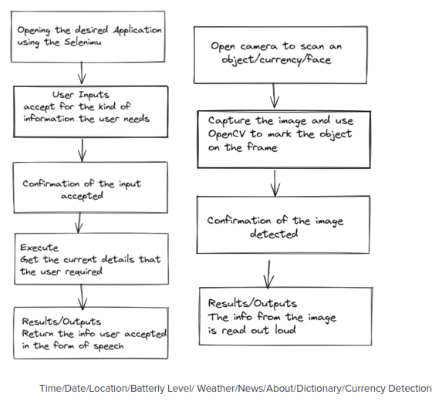

In this project there is only one user. The user queries command to the system. System then interprets it and fetches answer. The response is sent back to the user.

**CHAPTER 3 :-**

* **IMPLEMENTATION AND METHODOLOGY** :-

The system comprises a modular client-server distributed architecture. The system consists

of the main menu which first runs on the startup of the software and the website modules.

The client communicates with the server and back with the use of REST APIs, thus the

website modules are not local to the client. Throughout the system, the user communicates

with the software via a speech-to-text interface. The Google library of speech-to-text

(Speech Recognition) for Python is used for this purpose. For communicating the system’s

output to the user as well as for confirming the user input, the recognized input is

played back to the user using the Python text-to-speech library (pytssx3). The modules are

written in Python and make use of Selenium for automation of the respective module and

Beautiful Soup for scraping the contents of the web page. The “Script” component of each

module consists of customized code that entails the features of the website contained in the

module. For instance, the Wikipedia module consists of a Question and Answer and

A summary feature along with the traditional feature of reading out the entire article. The

former is implemented by training a BERT model on the Stanford Question Answering

Dataset (SQuaD). The APIs that hold the system together are written in Flask. The software

is operating system independent to support hassle-free application and usage

of the system.

Many researchers have contributed to this field. Various combinations of existing

technologies have been used. Braille systems, screen magnifiers, etc. went through some

developments but later faced technical issues.

Pilling et al. conducted a study to determine whether the internet provides opportunities for

disabled people to carry out activities which they were previously unable to do or whether

it leads to greater social exclusion. Sinks and kings et al. state that there is no known

research to determine the reasons people with disabilities can’t access the internet. Muller et

al on the other hand state that the primary barrier to inaccessibility is that of economic and

technical capabilities. This thought is seconded by Kirsty et al. who state that bad HTML

code and use of pdf causes a hindrance in accessing the internet for the visually impaired

Although the W3C mentions a list of guidelines for maintaining a high level of accessibility for

the visually impaired, Power et al. [5] state that only 50.4% of the problems encountered by

users were covered by Success Criteria in the Web Content Accessibility Guidelines 2.0

(WCAG 2.0) and 16.7% of websites implemented techniques recommended in WCAG 2.0

but the techniques did not solve the problems.

CHAPTER 4:-

* **SOFTWARE TESTING**

In order to build an intelligent virtual assistant one needs to combine in one project different technologies and tools from different areas:

• User input understanding: audio speech recognition, natural language understanding, user face recognition, sentiment analysis and opinion mining, etc.

• Intelligent reasoning: context understanding, dialogue management, social reasoning, domain specific knowledge, user model, etc.

• Output generation: sentence construction, gaze, posture and gesture generation, body animation control, audio speech generation, etc.

The software is designed to be light-weighted so that it doesn’t be a burden on themachine running it. This system is being build keeping in mind the generally availablehardware and software compatibility. Here are the minimum hardware and softwarerequirement for virtual assistant.

**Hardware:**

* Pentium-pro processor or later.
* RAM 512MB or more.

**Software:**

* Windows 7(32-bit) or above
* Python 2.7 or later
* Chrome Driver
* Selenium Web Automation
* SQLite

**CHAPTER 5 :-**

* **CODE ON SOME MODULES**
* **TIME**

Code :-

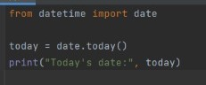

Output :-

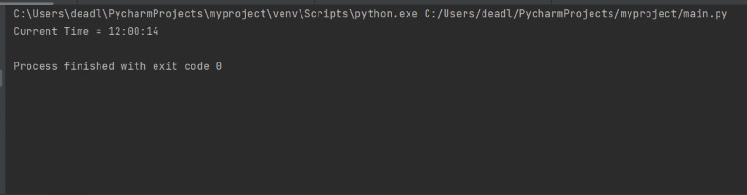

* **Date**

Code:-

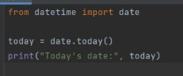

Output:-

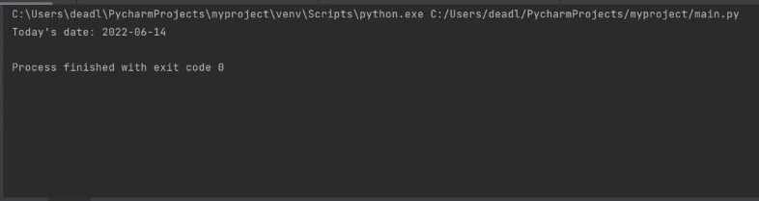

* **Location**

Code :-

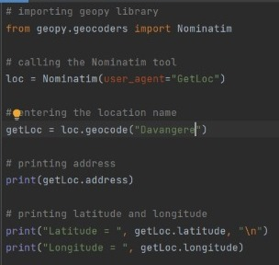

Output :-

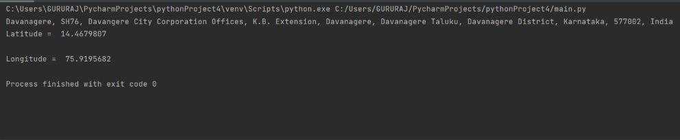

* **Battery level**

Code:-

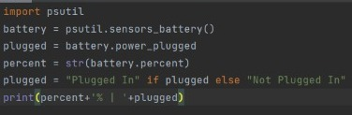

Output:-

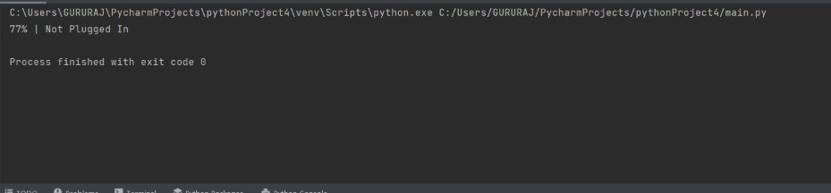

* **Weather**

Code:-

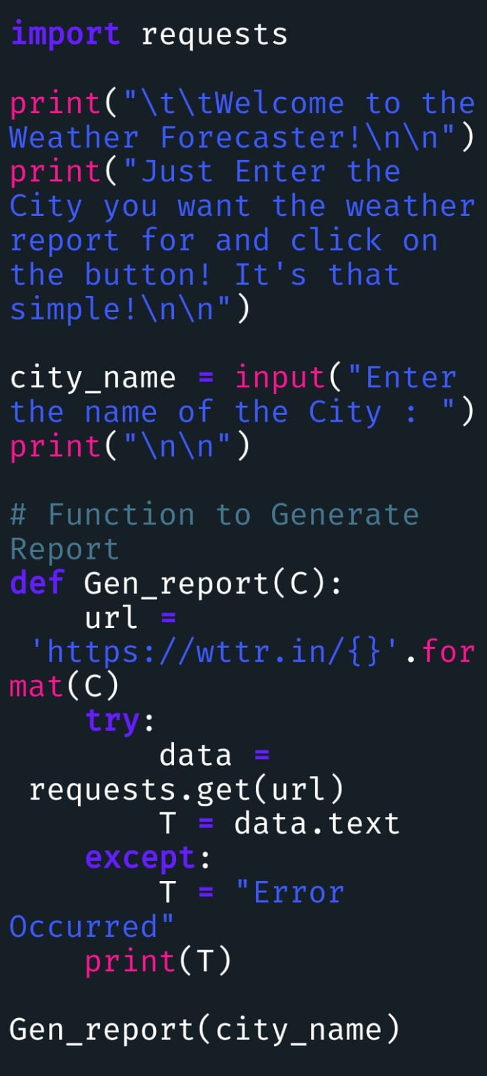

Output:-

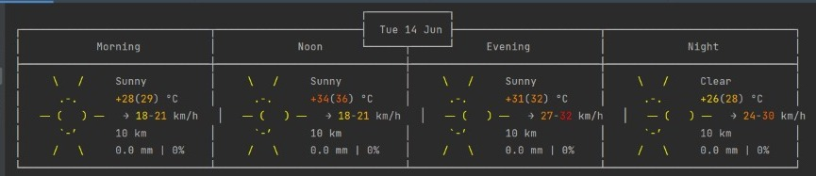

CHAPTER 6

* **Conclusion:-**

Various techniques to implement the aforementioned system are analyzed and summarized.

Different systems have different ways of implementation along with some limitations and

restrictions. These types of systems are very critical for multiple reasons and the occurrence

of an error in such a system/device may cause catastrophic damage and loss. The system

we are achieving overcomes the limitations of the already implemented systems. Our system

consists of a basic UI on a web-based application and comprises several Deep learning

models; some of them are object detection, face recognition using TF, TTS, speech

recognition and so on. These modules will work together and assist in vital activities.

Virtual Assistant provides the feature of providing answers to a particular question from a

given text of data, thus now the user does not have to read the entire text to figure out

the answer, he/she has to simply input the question, the software will find out the answer

from the text data on itself using machine learning. The software also provides a summary

of the text using machine learning, so the user doesn't have to read the entire thing and thumaking it easy to access the website. Thus, using machine learning and speech to text

techniques we make the task of accessing the website, which was earlier difficult

Now super easy, quick and efficient. Thus, we believe that virtual assistants for the

visually impaired.

**CHAPTER 7**

* **References:-**
* <https://drive.google.com/drive/folders/1cMLkB5coE4_ztgoo9FwGpU45nNFYjLqY?usp=sharing>
* Websites referred
  + [www.stackoverflow.com](http://www.stackoverflow.com)
  + www.pythonprogramming.net
  + www.codecademy.com
  + www.tutorialspoint.com
  + www.google.co.in
* Books referred
* Python Programming - Kiran Gurbani
* Learning Python - Mark Lutz
* YouTube Channels referred
* CS Dojo
* edureka!
* Documents referred
* Designing Personal Assistant Software for Task Management using SemanticWeb Technologies and Knowledge Databases- Purushotham Botla
* Python code for Artificial Intelligence: Foundations of Computational Agents- David L. Poole and Alan K. Mackworth